**Assignment 6**

Multiprocessor Programming 521288S

Miika Sikala 2520562, msikala18@student.oulu.fi

**Task:** OpenMP implementation of stereo-disparity algorithm (C/C++) and profiling.

**Expected result:** A working version of the implementation, a brief report (max 2-3 pages), saved output images all together in the form of a compressed folder (.zip file).

The report should contain about the task solved, brief description of your implementation, comparison of profiling information for pthread and OpenMP implementations and the final screenshot of your outputs asked to be displayed under the assignment.

**Introduction**

The threaded implementation was implemented simply by dividing the image to equal horizontal slices. Each thread would work on a separate strip at the same time, as shown in Figure 1.

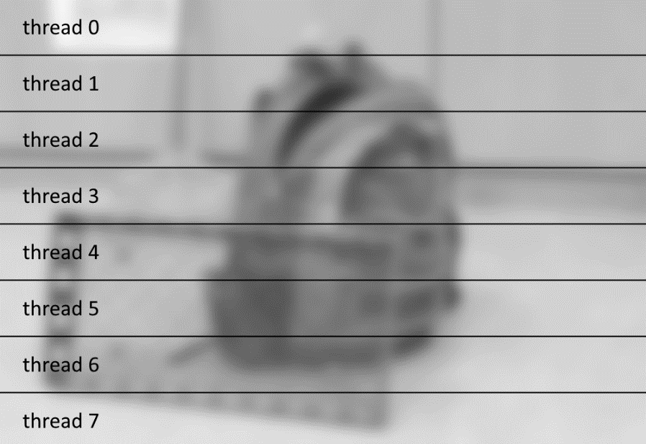

Figure 1. Implementation using Pthreads.

**Justifications:** work group size used is 16. This is optimized to my GPU, which has MAX_WORK_GROUP_SIZE of 256 (16x16). Also, the threaded implementation is optimized for my 8-core CPU. This can be changed by changing the NUM_THREADS definition in “Application.hpp”.

**Usage**

**Requirements:** since windows doesn’t support phtreads natively, you may have to install it manually. I was able to use pthreads out of the box with g++, but not with Visual Studio.

**To change the target device**, you can change the COMPUTE_DEVICE flag in “Application.hpp”. The options are TARGET_NONE (no parallelization), TARGET_PTHREAD (CPU parallelization using pthread) TARGET_GPU (OpenCL on GPU) and TARGET_CPU (OpenCL on CPU). You must re-compile the program for the change to take effect.

The application takes two to six input parameters, which are the image file names for the left and right images, and optionally some calculation parameters. See the example below, which uses image files img/im0.png and img/im1.png.

A makefile is provided for compiling with g++.

Compiling using *g++*:  
make

Running:  
stereo.exe img/im0.png img/im1.png 15 55 8 4

# Arguments: LEFT_IMG RIGHT_IMG [WINDOW_SIZE=9] [MAX_SEARCH_DIST=32]  
# [CROSS_CHECK_THRESHOLD=8] [DOWNSCALE_FACTOR=4]

**Testing and benchmarking the implementations**

The results (intermediate and final) are stored in “img” folder. Figure 2 shows the execution of the program for three different compute targets.

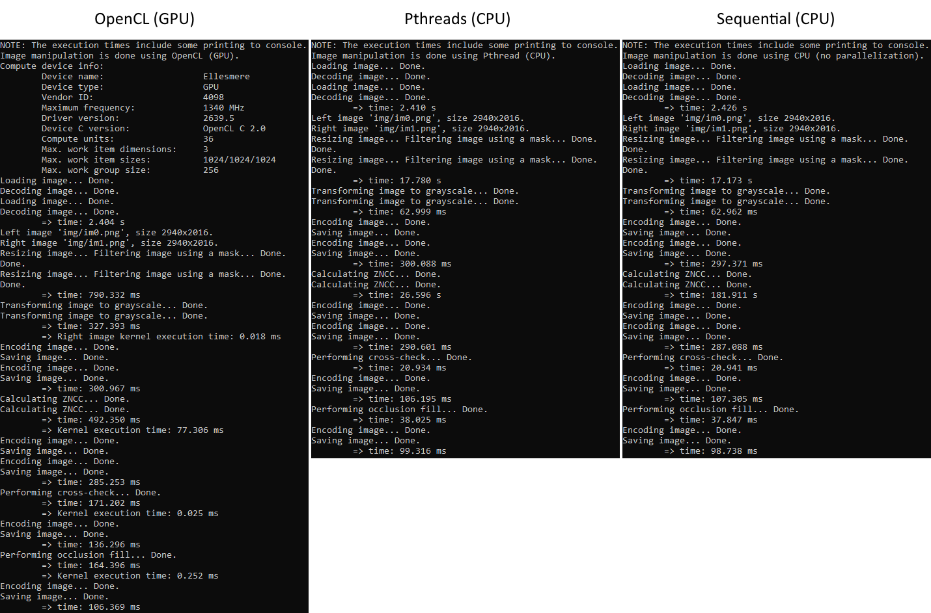

Figure 2. Execution of the program using all three compute targets (OpenCL, Pthreads, sequential).

The benchmarking was done using a simple occlusion fill algorithm, which simply seeks the nearest non-zero pixel on the left. However, another occlusion fill kernel was implemented, which seeks the nearest non-zero pixel in square-like spiral.

Used configuration:

window size: 15  
maximum search distance: 55  
cross-checking threshold: 8  
downscaling factor: 4

Execution times:

|  |  |  |  |  |
| --- | --- | --- | --- | --- |
| **Operation** | **CPU (sequential)** | **CPU (Pthreads)** | **GPU (OpenCL)** | **Kernel only** |
| Load + decode | 2.431 s | 2.426 s | 2.435 s | - |
| Resize | 17.566 s | 17.017 s | 748.777 ms | - |
| Convert to grayscale | 62.078 ms | 62.659 ms | 294.004 ms | 0.034 ms |
| Encode + save | 298.543 ms | 300.209 ms | 301.397 ms | - |
| Calculate ZNCC | **181.237 s** | **26.474 s** | **469.242 ms** | 156.45 ms |
| Encode + save | 333.823 ms | 334.044 ms | 285.672 ms | - |
| Cross-check | **21.999 ms** | 21.991 ms | **148.863 ms** | 0.026 ms |
| Encode + save | 122.874 ms | 124.158 ms | 137.731 ms | - |
| Occlusion fill | **38.629 ms** | 39.909 ms | **144.385 ms** | 0.200 ms |
| Encode + save | 109.111 ms | 111.126 ms | 105.542 ms | - |
| **Total** | **202.221 s** | **46.911 s** | **5.071 s** | **156.710 ms** |

As can be seen, the threaded implementation already improves ZNCC calculation significantly: the eight-thread implementation of ZNCC calculation took around 15 % of the sequential implementation’s time. Let alone the OpenCL implementation, which only took 0.26 % of that!

*Kernel only* shows the kernel execution time when applicable. Notice the significant overhead of transferring the images between host and device memory (total of 900 ms). Using OpenCL in cross-checking and other very simple algorithms actually worsens the performance due to the transfer times. This is one point of improvement in the future.

The *benchmark.txt* file shows more details of the benchmarking.

**Discussion**

The current implementation requires that the intermediate calculation results are transferred between the host and compute device memory multiple times. This is due to the modularity of the implementation (easy to make different computations). If we wanted to make the implementation as optimal as possible, we could minimize the number of transfers between the memories. This may be done in future implementations.

Reporting

|  |  |
| --- | --- |
| **Task** | **Hours** |
| Pthreads implementation | 3 h |
| OpenCL implementation | 8 h |
| Refactoring | 1 h |
| Benchmarking & writing the report | 2 h |
| **Total** | **14 h** |